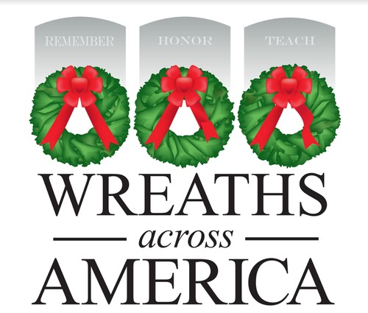
Knights of Columbus, St. Philip the Apostle Council 17028
Is a proud supporter of Wreaths Across America.
The wreaths are placed at Christmas time, this year they will be placed by volunters at Veterans graves at St. Anthony’s Cemetery on Grofftown Road in Lancaster. This event will take place on Saturday, December 19th at 12:00 noon.
Each wreath costs $17.00, of that amount $5.00 comes back to the Council which will help us with other projects at the Church, including our Faith and community programs.
To purchase a wreath using your smartphone scan the QR code below that will take you to our sponsorship page.
This Memorial Day show your support of our fallen heros.
Thank you for your support.


